**University of Virginia**

**Department of Politics and Studies in Women and Gender**

**Fall 2013**

**Denise Walsh PLCP 3350**

**Gibson Hall S454 Gibson Hall 141**

**Office Hours: Tues. & Th. 3:30-4:30 pm T/Th 2:00-3:15**

**denise@virginia.edu**

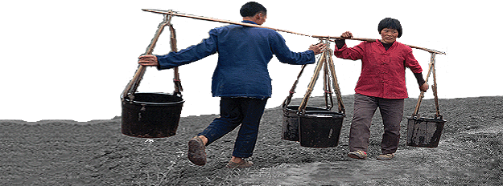

**Gender Politics in Comparative Perspective**

The purpose of this course is to introduce students to the field of Gender and Comparative Politics. Our focus will be on the state, how power is gendered, and the effects on women and men in the global South. Students will develop skills in comparative political analysis, gain a deeper understanding of politics in the global South and how these states construct gender, and strengthen their research and writing skills.

We begin with a discussion of feminist theory and methodology, gender, and the state. We then investigate core issues in comparative politics, including democratic transition, citizenship, electoral systems, and migration, through a gender lens. Case studies include the prospects for women’s rights in North Africa, quotas for women in politics in Argentina, and the gendered impact of globalization in China. Readings are drawn from a number of disciplines, including politics, anthropology, political economy, and women’s studies.

**Course Requirements**

Grading consists of attendance, participation, and homework (20%), an in-class exam (20%), an in-class debate with position papers (25%), a research proposal (5%), and a short research paper (30%).

**Class Policies**

No computers, cell phone, ipads, etc. should ever be used during class without permission of the instructor.

Do not eat lunch in class.

Follow the [honor code](http://www.virginia.edu/uvatours/shorthistory/code.html). If you have a question about [plagiarism](http://www.virginia.edu/honor/wp-content/uploads/2012/09/PlagiarismSupplement2011.pdf), ask.

Late discussion postings and presentations from discussion leaders is not accepted.

Late research papers and proposals lose 3 points each day for the first two days. Later work will only be accepted as determined by the instructor.

All students are expected to attend every class session, with the exception of illness or an emergency. All other absences will be unexcused and detract from your participation grade. In the event of an excused absence, please arrange to get the lecture notes and announcements from another student in the class.

My preferred communication with students is in person (during office hours, after class). When using email do not expect an immediate response. If there is an emergency, indicate that in the subject line.

For information about my research, courses, advising, and letters of recommendation, please consult my [webpage](http://denisewalsh.weebly.com/).

See the file “Assignments” on Collab under the syllabus tab for additional instructions.

**Course Readings**

All readings are available on Collab unless otherwise noted.

The readings in this course can be challenging. Print them out and write on them. I know you can mark them up on your computer without printing and that printing costs money. So do books. Consider these readings your books, print them up, and write on them. Writing is thinking.

*Occasional changes to the syllabus are possible and will be announced in advance.

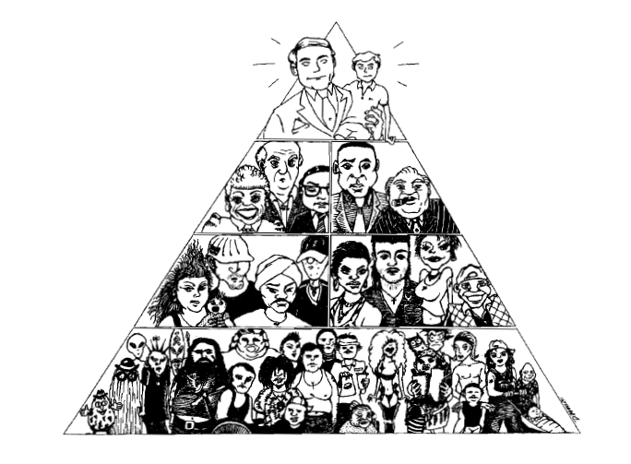

**Course Outline.**

***Part I. Theory and Method***

**Class 1: What is a “comparative politics of gender” and why do we need it?**

*Recommended:* Karen Beckwith, 2010, “Introduction: Comparative Politics and the Logics of a Comparative Politics of Gender,” *Perspectives* 8 (1): 159-168.

**Class 2: What are gender policies and why do they vary across states?**

Joya Misra and Lesli King, 2005 “Women, Gender and State Policies,” in Thomas Janoski, Robert Alford, Alexander Hicks and Mildred A. Schwartz, *The Handbook of Political Sociology: States, Civil Societies, and Globalization*, pp. 135-152.

**Class 3 (Sept. 3): What is a feminist approach to the state and what is feminist methodology?**

Homework #1

Georgina Waylen, 1998, “Gender, Feminism and the State: an Overview,” in Vicky Randall and Georgina Waylen, eds., *Gender, Politics and the State*, London and New York: Routledge, pp. 1-17.

Sandra Harding, 1987, “Introduction: Is There a Feminist Method?” in Sandra Harding ed., *Feminism & Methodology*, Bloomington: Indiana University Press, pp. 1-14.

**Class 4 (Sept. 5): What is gender and how is it related to the state?**

Karen Beckwith, 2005, “A Common Language of Gender?” *Politics and Gender* 1(1): 128-136.

Lisa D. Brush, 2003, “Where the Power Is,” *Governance and Gender*, Walnut Creek: AltaMira Press, pp. 3-22.

Homework film clip: [“Tough Guise: Violence, Media & the Crisis in Masculinity”](http://www.youtube.com/watch?v=3exzMPT4nGI)

In-class film clips: [Tank Ride](http://www.history.com/videos/tank-ride#tank-ride), [Miss Representation](http://www.missrepresentation.org/the-film/)

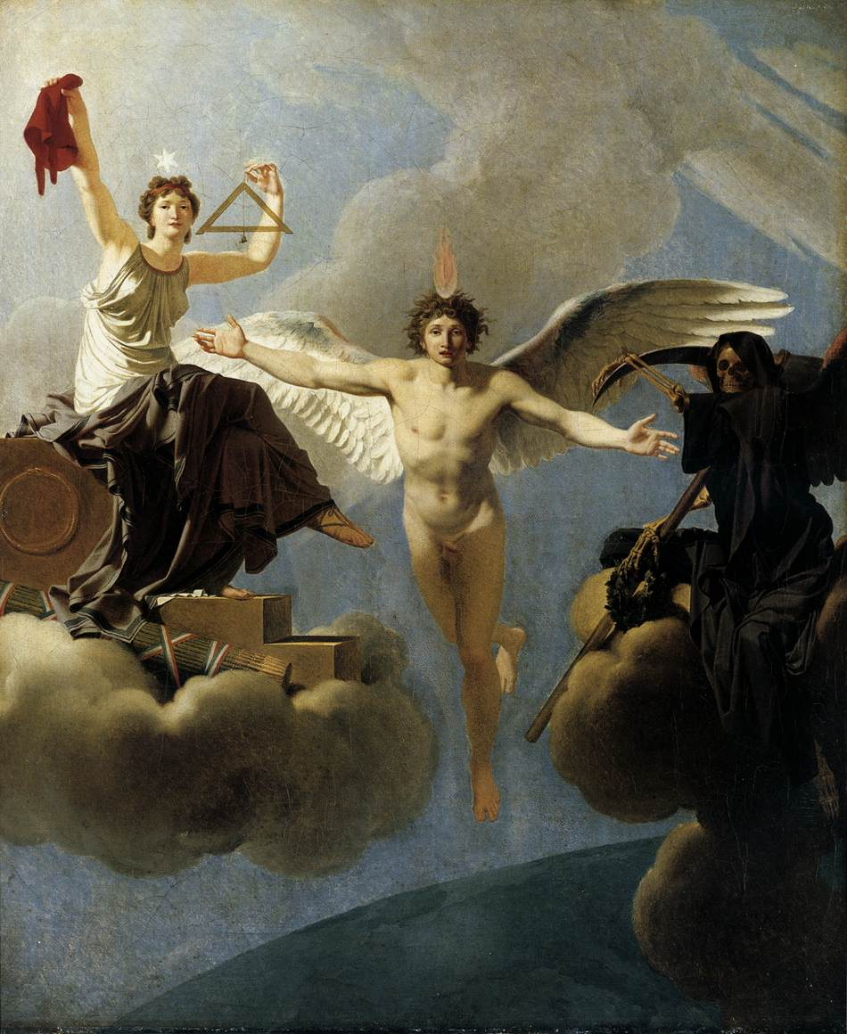

**Last Day to Add a Class: Sept. 11**

**Class 5 (Sept 10):** **What is the relationship between gender and the state beyond the “West”?**

Georgina Waylen, 1996,“Analysing Gender in the Politics of the Third World,” in *Gender in Third World Politics,* Boulder: Lynne Rienner Publishers, pp. 5-23.

Shirin Rai, 1996, “Women and the State in the Third World,” in Haleh Afshar ed., *Women and Politics in the Third World*, New York: Routledge, pp. 25-39.

**Last Day to Drop a Class w/o Penalty: Sept. 12**

**Class 6 (Sept. 12): How and why has “Western” feminism been imperialist?**

Bring your remaining questions about the Rai reading from Class #5 to class today.

Oyeronke Oyewumi, 2003, Ch. 2 “THE WHITE WOMAN’S BURDEN: African Women in Western Feminist Discourse,” in Oyeronke Oyewumi, ed., *African Women and Feminism: Reflecting on the Politics of Sisterhood*, Trenton, NJ: Africa World Press, pp. 25-44.

In-class discussion of Femen’s Topless Jihad.

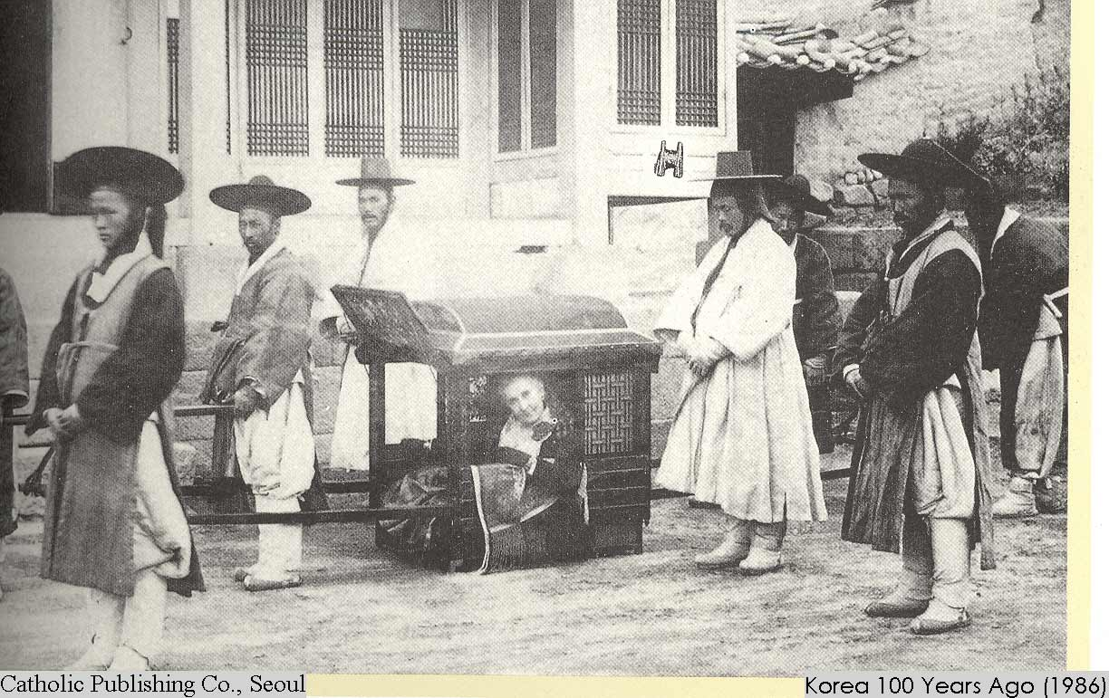

**Class 7 (Sept. 17): Why was gender at the core of empire?**

Maria Mies, 1998, “Colonization and Housewifization,” *Patriarchy and Accumulation on a World Scale: Women in the International Division of Labor*, London: Zed Books, pp. 90-111.

Laura Ann Stoler, 1989, "Making Empire Respectable," *American Ethnologist* 16 (4): 634-660.

**Class 8 (Sept. 19): What are women’s interests?**

Deniz Kandiyoti, 1996, “Bargaining with Patriarchy,” in Nalini Visvanathan, Lynn Duggan, Laurie Nisonoff and Nan Wiegersma eds., *Women, Gender and Development Reader*, London and New Jersey: Zed Books, pp. 86-92.

Maxine Molyneux, 2001, “Mobilisation Without Emancipation? Women’s Interests, the State and Revolution in Nicaragua,” *Women’s Movements in International Perspective: Latin America and Beyond*, Palgrave Macmillan, pp. 38-59.

Homework Film Clip: [“Nicaragua: An Unfinished Revolution Part 1”](http://www.youtube.com/watch?v=hAlCHUwpQJs&list=PL0A0FC39E491FF6F8&index=1) [and Part II](http://www.frequency.com/video/nicaragua-unfinished-revolution-17-jul/106777301/-/5-201753)

**Class 9 (Sept. 24): Are women’s rights in women’s interests?**

Andrea Cornwall and Maxine Molyneux, 2006, “The Politics of Rights – Dilemmas for Feminist Praxis: an Introduction,” *Third World Quarterly* 27:7: 1175-1191 (Collab).

Exam review.

**Class 10 (Sept. 26): *In-class Exam\***

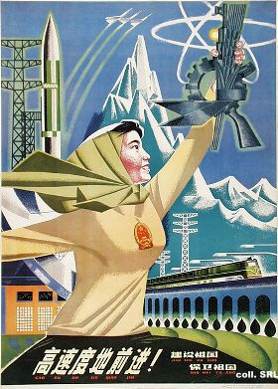

***Part II. Gender & Political Transformation***

**Class 11 (Oct. 1): How and why have liberation movements mobilized women?**

Karen Kampwirth, 2002, “New Roles for Sandino’s Daughters,” *Women and Guerrilla Movements: Nicaragua, El Salvador, Chiapas, Cuba*, Pennsylvania University Press, pp. 21-43.

Ilja A. Luciak, 2001, “The Gender Composition of the Central American Guerrilla Movements,” *After the Revolution: Gender and Democracy in El Salvador, Nicaragua, and Guatemala*, Baltimore: Johns Hopkins Press, pp. 1-31.

Homework Film Clip: [“Nicaragua: An Unfinished Revolution, Part III”](http://www.youtube.com/watch?NR=1&v=lxCImH9ZOq0)

In-class Film Clips: [“Full Metal Jacket”](http://www.youtube.com/watch?v=aUc62jD-G0o); [The Invisible War](http://www.notinvisible.org/)

**Class 12 (Oct. 3): How and why do women’s movements emerge?**

Susan Franceschet, 2004, “Explaining Social Movement Outcomes: Collective Action Frames and Strategic Choices in First-and Second-Wave Feminism in Chile,” *Comparative Political Studies* 37: 499-530.

Lisa Baldez, 2003, “Women’s Movements and Democratic Transition in Chile, Brazil, East Germany and Poland,” *Comparative Politics* 35 (3): 253-272.

Homework Film Clip: [The Overthrow of Democratic Chile](http://www.youtube.com/watch?v=X6kkaIfy9wU) Part I and [Part II](http://www.youtube.com/watch?v=7QbuGllw66A)

In-class Film Clip: “[Because our Cause is Just](http://www.learningpartnership.org/arab-spring-women-democracy)”

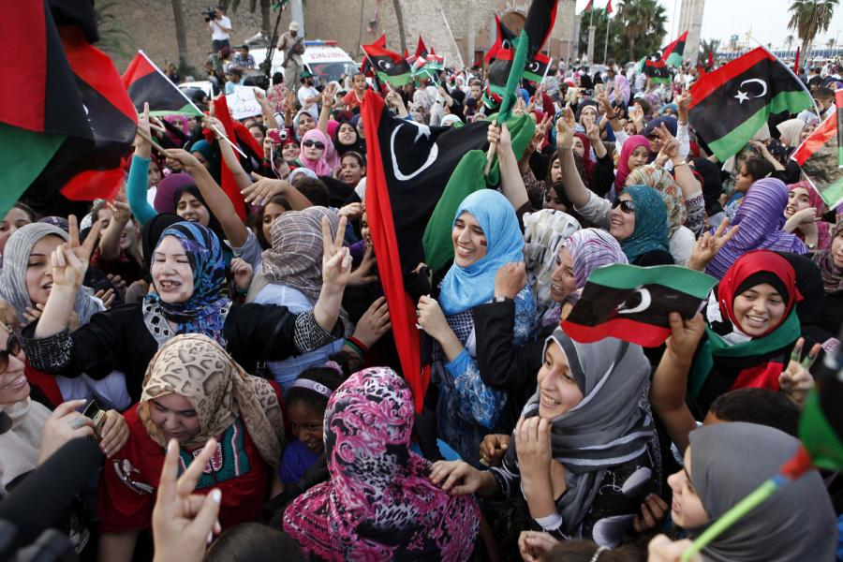

**Class 13 (Oct. 8): Will a strong, autonomous feminist movement emerge in Egypt? Why or why not?**

Homework #2 due today

Guest Speaker: [Nancy Youssef](http://www.mcclatchydc.com/nancy-youssef/), award-winning Middle East and Islamic World correspondent for McClatchy Newspapers.

Nadje Al-Ali, 2000, *Secularism, Gender and the State in the Middle East: The Egyptian Women’s Movement*, Cambridge University Press: Ch. 2.

FIDH (Federation International des Droits de l’Homme), 2012, “[Women and the Arab Spring: Taking Their Place?](http://www.europarl.europa.eu/document/activities/cont/201206/20120608ATT46510/20120608ATT46510EN.pdf)” Egypt: 16-25.

Carolyn Barnet, “[Egypt: Fighting for Women’s Rights in the Aftermath of the Revolution](http://www.wluml.org/node/7255),” *Women Living under Muslim Law*, June 2011.

al Jazeera, [Egypt's feminists prepare for a long battle](http://www.aljazeera.com/indepth/features/2012/01/2012117113758961894.html), February 7, 2012.

Egyptian Women’s Charter, 2011, “The Alliance for Arab Women and the Egyptian Women’s Coalition.”

Zaid Al-Ali, “[The New Egyptian Constitution: An Initial Assessment of its Merits and Flaws](http://www.opendemocracy.net/zaid-al-ali/new-egyptian-constitution-initial-assessment-of-its-merits-and-flaws),” *Open Democracy*, December 26, 2012.

Nancy Youssef, “[For Egypt’s Women, Fear of Rape now Governs Cairo’s Tahirir Square](http://www.mcclatchydc.com/2013/02/25/183900/for-egypts-women-fear-of-rape.html#.UjoRCNCYaJJ),”  *McClatchy*, February 25, 2013.

Homework Film Clip: [After the Arab Spring, A Feminist Summer?](http://www.youtube.com/watch?v=zwsXSzQxsCE)

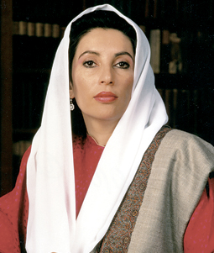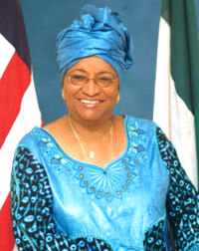

***Part III. Women’s Rights***

**Class 14 (Oct. 10): Are quotas effective? Why or why not?**

Gretchen Bauer, 2008, “Fifty/Fifty by 2020,” *International Feminist Journal of Politics* 10 (3): 348-368.

Susan Franceschet and Jennifer Piscopo, 2008, “Gender Quotas and Women’s Substantive Representation: Lessons from Argentina,” *Politics & Gender* 4: 393-425.

Browse the Inter-Parliamentary Union website, starting here: <http://www.ipu.org/wmn-e/classif.htm>

In-class Film Clip: [Miss Representation](http://www.upmoviz.com/streaming-documentary/807-miss-representation-online.html)

In-class Film Clip: [Women Rank High in Rwanda’s Government](http://www.youtube.com/watch?v=pXolW3WhUeI)

**No Class (Oct. 15): *Reading Day\***

**Class 15 (Oct. 17): What is state feminism and why is it controversial among feminists?**

Philomina E. Okeke-Ihejirika and Susan Franceschet, 2002, “Democratization and State Feminism: Gender Politics in Africa and Latin America,” *Development and Change*, 33 (3):  439-466.

Gulay Caglar, 2013, “Gender Mainstreaming,” *Politics & Gender* 9 (3): 336-334.

In-class Film Clip: [South African Football Association (SAFA) Challenged on Lack of Gender Equality](http://www.youtube.com/watch?v=rLsSucdq814)

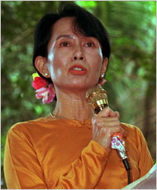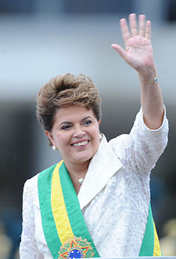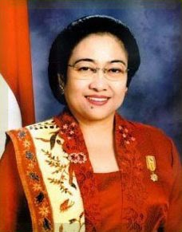

**Class 16 (Oct. 22): What can women’s organizations accomplish and how?**

Melinda Adams and Alice Kang, 2010, “Regional Advocacy Networks and the Protocol of the Rights of Women in Africa,” *Politics & Gender* 3(4): 451-474.

Mala Htun and Laurel Weldon, 2012, “The Civic Origins of Progressive Policy Change: Combating Violence against Women in Global Perspective, 1975-2005,” *American Political Science Review* First View: 1-22.

In-class Film Clip: [2008 Africa Prize for Leadership](http://www.youtube.com/watch?v=ckpmIH1rHHo&feature=related)

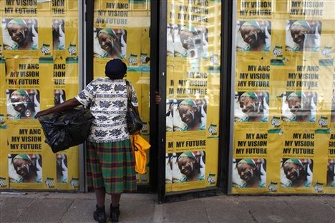

**Class 17 (Oct. 24): Why are women’s rights about elite men?**

Mounira Charrad, 2007,“Contexts, Concepts and Contentions: Gender Legislation as Politics in the Middle East,” *Hawwa* 5: 55-72.

Denise Walsh, 2012, “Party Centralization and Debate Conditions in South Africa,” in Susan Franceschet, Mona Lena Krook, and Jennifer Piscopo, eds., *The Impact of Gender Quotas: Women’s Descriptive, Substantive, and Symbolic Representation*, Oxford University Press: 119-135.

Homework Clip: [1994 South Africa WHY](http://www.youtube.com/watch?v=52DMSIE2jYg)

In-class Film Clip: “Tunisia: Women Fight to Keep 50 Years of Equality”

**Class 18 (Oct. 29): Is religion bad for women?**

Mala Htun and Laurel Weldon, under review, “Religion, the State, and Women’s Rights: Comparative Analysis of Sex Equality in Family Law.”

Read “Class Debate” under the Resources tab on Collab.

In-class discussion of Class Debate and Position Papers, Debate Teams assigned, Debate Teams meet.

**Class 19 (Oct. 31):** **In-Class Debate and Position Papers Due**

Turn your position papers in on Collab and also bring a hard copy with you to class for reference.



***Part V: Gender & the Global Economy***

**Class 20 (Nov. 5):** **How is the global economy gendered?**

Jean L. Pyle and Kathryn B. Ward, 2003, “Recasting Our Understanding of Gender and Work During Global Restructuring,” *International Sociology* 18 (3): 461-489.

Lourdes Beneria, Carment Diana Deere, and Naila Kabeer, 2012, “Gender and International Migration: Globalization, Development, and Governance,” *Feminist Economics* 18 (2): 1-33.

Start making a list of possible research topics related to gender and the global economy for your final paper and a possible country(ies) to research.

For Homework: [40 Maps that Explain the World: #1, #7, #10, #35](http://www.washingtonpost.com/blogs/worldviews/wp/2014/01/13/40-more-maps-that-explain-the-world/)

In-class Film clip: “Life and Debt”

In-class Trailer: [“Inside Job”](http://www.sonyclassics.com/insidejob/)

In-class Film clip: [“Greek Economic Crisis”](http://www.huffingtonpost.com/2012/05/17/richard-parker-greece_n_1524951.html)

In-class Film clip: [“Inequality for All”](http://www.democracynow.org/2013/9/13/inequality_for_all_robert_reich_warns)

In-class film clip: [“Italy’s Brewing Anti-Immigrant Climate”](http://www.youtube.com/watch?v=D6Vn_aXkAOk)

Class 21 (Nov. 7): Do development programs work for women? Why or why not?

Lamia Karim, 2008, “Demystifying Micro-Credit: The Grameen Bank, NGOs, and Neoliberalism in Bangladesh,” *Cultural Dynamics* 20: 5-29.

Andrew Beath, Fotini Christia, Ruben Enikolopov, 2013, “Empowering Women through Development Aid: Evidence from a Field Experiment in Afghanistan,” *American Political Science Review* 107 (3): 540-557.

Homework Film Clip: [The Micro Debt](http://www.flipthecoin.org/?p=346)

Discussion of research paper assignment (read the details on the Assignments file under the Syllabus tab on Collab).

Research Paper Partners posted on Collab.

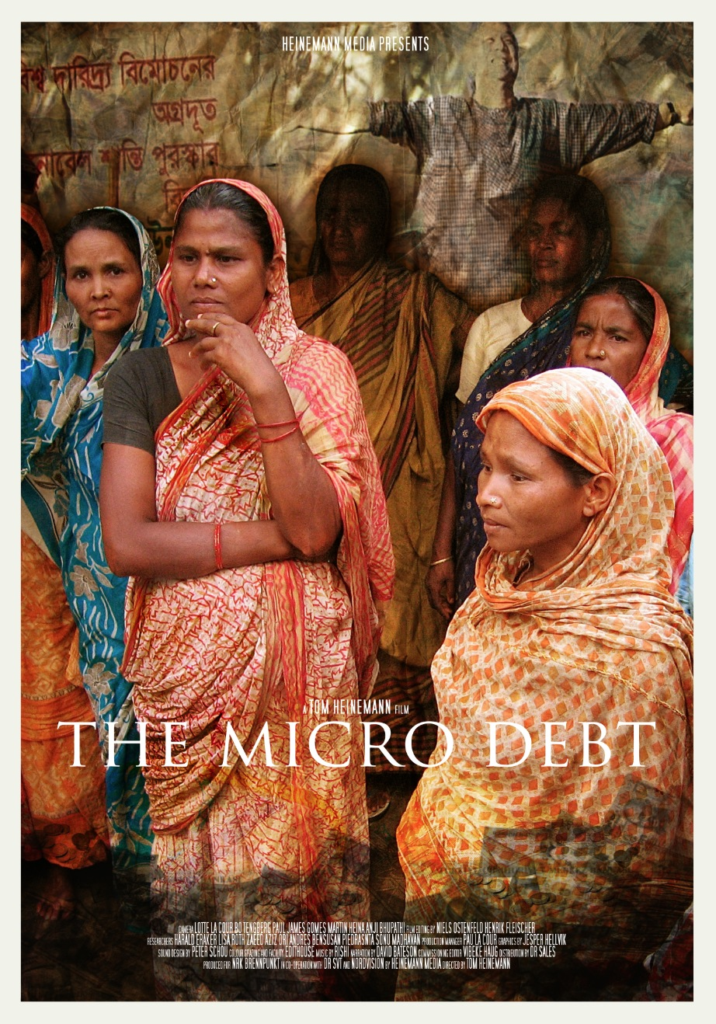 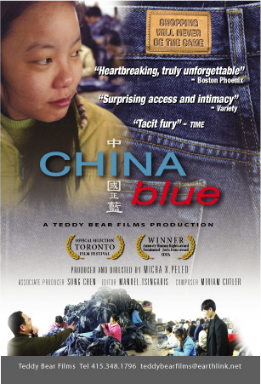 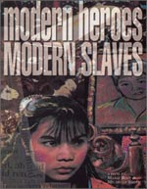

**Class 22 (Nov. 12): What factors shape the industrial sexual division of labor?**

Teri L. Caraway, 2007, “Feminized Ghettos? The Structural Contours of Women’s Employment,” in *Assembling Women: The Feminization of Global Manufacturing*, Cornell University Press, pp. 36-61.

Esther Ngan-ling Chow, 2008, “Empowerment of Women Migrant Factory Workers in South China: Opportunities and Contradictions,” in Carolyn M. Elliott, *Global Empowerment of Women: Responses to Globalization and Politicized Religions*, Routledge, pp. 77-100.

Homework Trailer: [“Last Train Home”](http://www.youtube.com/watch?v=P313uy9hni4)

In-class Film Clip: “China Blue”

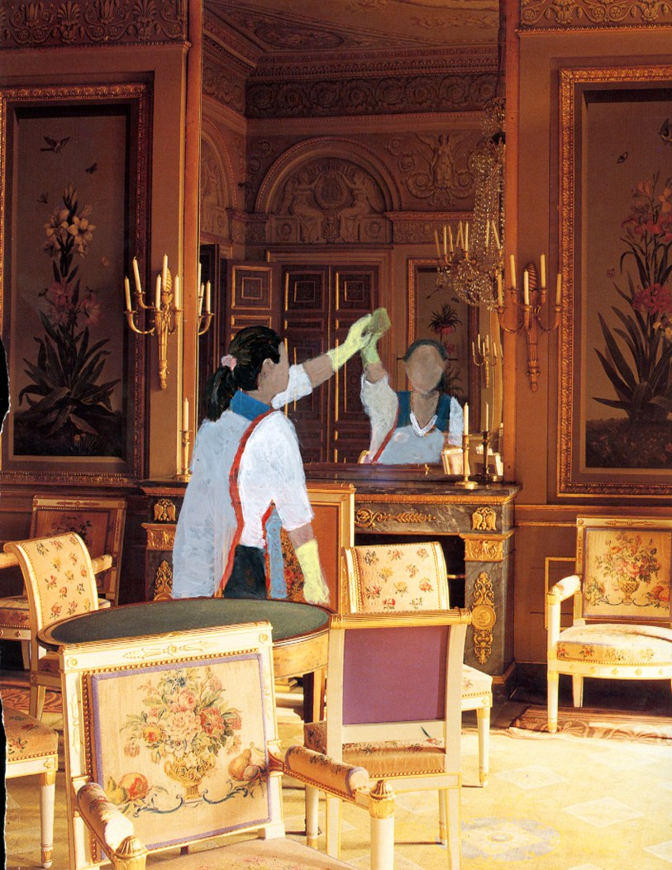

**Class 23 (Nov. 14):**  **Who migrates and why? How does it affect gender norms?**

Homework #3

Nana Oishi, 2002, “Gender and Migration: An Integrative Approach,” *The Center for Comparative Immigration Studies*, Working Paper No. 49, March: 1-20.

Lan Anh Hoang and Brenda S. A. Yeoh, 2011, “Men and Masculinities in the Vietnamese Transnational Family,” *Gender & Society* 25(6): 717-739.

Homework film clip: “[International Migration”](http://www.youtube.com/watch?v=lOZmqIwqur4)

For Homework: [40 Maps that Explain the World: #11, #12,#30](http://www.washingtonpost.com/blogs/worldviews/wp/2014/01/13/40-more-maps-that-explain-the-world/)

In-class Film Clip: “Modern Heroes, Modern Slaves”

In-class Film Clip: “[Anger at Beheading of Sri Lankan Maid](http://www.aljazeera.com/news/middleeast/2013/01/20131107434432906.html)”

In-class Film Clip: “[Egyptians Mourn Drowned Immigrants](http://www.aljazeera.com/video/middleeast/2012/08/201283083349982493.html)”



**Class 24 (Nov. 19): What is human security and why is prostitution a transnational problem?**

Jennifer K. Lobasz, 2009, “Beyond Border Security: Feminist Approaches to Human Trafficking,” *Security Studies* 18: 319-344.

Kyoung-Ho Shin, 2011, “A Theoretical View of the Globalizing Sex Industry: World System Position, Local Patriarchy, and State Policy in South Korea,” in Esther Ngan-ling Chow, Marcia Texler Segal, Lin Tan eds., [*Analyzing Gender, Intersectionality, and Multiple Inequalities: Global, Transnational and Local Contexts*](http://site.ebrary.com.proxy.its.virginia.edu/lib/uvalib/docDetail.action?docID=10482209), Emerald: 75-94 (available via Virgo, sign in using your Netbadge).

For Homework: [40 Maps that Explain the World: #17](http://www.washingtonpost.com/blogs/worldviews/wp/2014/01/13/40-more-maps-that-explain-the-world/)

In-class Film Clip: [Italian Sex Trade Fueled by Human Trafficking](https://www.youtube.com/watch?v=bBuLnVbaNAg)

**Class 25 (Nov. 21): Doing Research *Meet in Alderman Electronic Classroom\***

Brooke Ackerly and Jacqui True, 2010, “Question-Driven Research: Formulating a Good Question,” *Doing Feminist Research in Political Science and Social Science*, Hampshire: Palgrave Macmillan, Ch. 4.

Read the pages on [Research Overview](http://owl.english.purdue.edu/owl/resource/552/01/) and [Primary Research](http://owl.english.purdue.edu/owl/resource/559/1/)

Come to class with a good research question written out and ready to research.

Guest speaker: Gary Treadway, Librarian for Politics and History, Coordinator of Humanities and Social Sciences Collection.

Students will work with a writing partner at the end of class to develop a research topic and strategies for finding sources.

**\*Thanksgiving Break: November 27- December 1\***



**Class 26 (Nov. 26): Research Paper Proposal Due**

Your research proposal needs a question that you hope to answer. Your answer is a claim. You can’t have a confirmed claim until you do the research and write up the paper. Until then, you have a tentative claim, or a hypothesis.

**Class 27 (Dec. 3):** **Writing Well**

Read the discussion about how to do a [research paper](http://www7.esc.edu/hshapiro/writing_program/students/Handouts/main/research_paper.htm#asks) and browse this [site](http://owl.english.purdue.edu/owl/resource/587/1/) and this [one](http://www.groundsforargument.org/drupal/sitemap).

Guest Speaker: Director, UVa Writing Center

In-class writing exercise: bring a copy of your research proposal to class.

Class 28 (Dec. 5): Outlining and Evidence

Read the discussion about how to do an [outline](http://owl.english.purdue.edu/owl/resource/544/1/) and browse this site for additional research paper writing tips. Click [here](http://web.psych.washington.edu/writingcenter/writingguides/pdf/outline.pdf) for an explanation and illustration of how to make an outline for a research paper, and [here](http://www.groundsforargument.org/drupal/reasons/dist/LRSintheWild) for a a parody of Mary Kate Olson on the difference between reasons and evidence, and [here](http://www.groundsforargument.org/drupal/evidence/what-counts/LRSintheWild) for a clip from the TV show “Mythbusters”on evidence.

Mary Hawkesworth, 2006, “Evidence,” *Feminist Inquiry: From Political Conviction* to *Methodological Innovation*, Rutgers University Press: 98-117.

In-class exercise: [Slavery Footprint](http://www.slaveryfootprint.org/); [40 Maps that Explain the World: #9](http://www.washingtonpost.com/blogs/worldviews/wp/2014/01/13/40-more-maps-that-explain-the-world/)

Students will work with a writing partner to develop the outline for their research papers. Bring a copy of your revised research proposal with you to class.

Dec. 16: Research Paper due at noon on collab

For 2 bonus points on the final research paper, make comments on a draft of your writing partner’s research paper. Then copy and paste your comments into the text box when you turn this assignment in on collab. Turn your research paper in as an attachment.

Writing is thinking, and papers require several drafts. For general suggestions on how to revise your research paper see “[Rewriting or Revising](http://www8.esc.edu/esconline/across_esc/writerscomplex.nsf/3cc42a422514347a8525671d0049f395/cfeb45e91f1a38cd852569c3006c4335?OpenDocument)”