Denise Walsh PLCP 4500
Levering Hall 202 Bryan Hall 334
Office Hours: Wednesday 7:30-8:30 pm Wednesday, 5-7:30pm
denise@virginia.edu

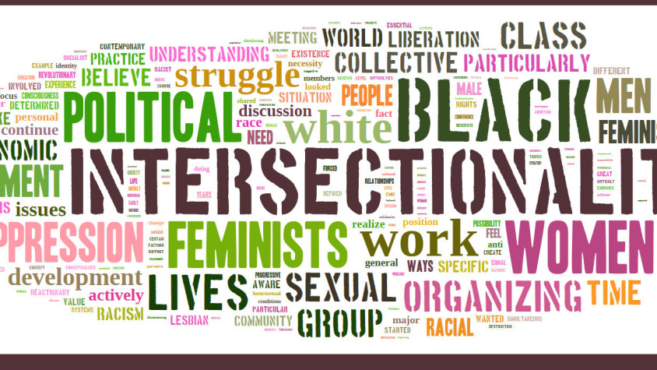

Identity Politics
2019

What is identity and where do identities come from? How and why do groups pursue identity politics? How do identity groups interact with one another? This course investigates these questions by analyzing an array of identity categories, such as class, race, sexuality and religion, in comparative perspective. We begin with a discussion of our core concept and the emergence of identity politics in the United States. Next, we discuss the different approaches that political scientists use to analyze identity formation. In the second section of the course we explore identity formation and identity politics around the globe. Cases include class politics in South Korea, indigenous movements in Latin America, and nationalism and sexuality in Eastern Europe. In the third section of the course, we analyze different relations among politicized identities, including conflict in France, coalition building in South Africa, and social sorting in the United States. The course concludes with student research presentations in preparation for the final research paper.

Course Requirements
Participation (20%)
Student attendance, preparation, and active participation in class are required. The instructor takes attendance at the beginning of class and after break. Arriving in class late or leaving early will count against your participation grade. Quality of participation matters; good questions count as much as answers. The instructor will grade participation two times during the semester (mid-term and finals).

Presentations (15%)
In teams of 2, students will sign up for 10-15-minute presentations during one class session. Sessions available for student presentations are designated with an * on the syllabus. Students should meet together beforehand to discuss the readings and plan the presentation. Do not divide up the readings. Both students should present on all of the material. A conversation between presenters should occur. Assume everyone has done the reading.

The instructor may comment, ask questions, or otherwise intervene during the presentation to facilitate student learning. Do not interpret this as a critique of the presentation. Interruptions from the instructor and interaction with the class do not count against student presentation time.

Presentation requirements:
- Create a powerpoint for the presentation.
- Introduce the day’s topic with relevant background on 1 slide.
- Present the key question and answer for each assigned reading on a slide: 2 sentences maximum. Take the time to discuss the Q&A so your audience can copy down the information and think about it.
- Select 1-2 key concepts that the author uses and summarize them on one slide. Don’t choose more than 2 concepts.
- Select 1-2 pieces of evidence that you think best support the author’s argument and summarize them on one slide. Don’t read quotes or long pages of notes; instead, explain the ideas simply, in your own words. Don’t choose more than 2 pieces of evidence.
- The presentation should be between 10 and15 minutes long. The instructor will stop any presentation that goes beyond 15 minutes (excluding questions and comments from the class).
- In addition to the presentation, students will design an 8 to10-minute class activity, e.g., a mini debate, a film clip, group questions. Be sure to explain the purpose of the activity and its key points. Students must not do the same activity as the previous presenters. Variety keeps our attention. You may include the activity at any point during the presentation. Presenters who do not include an activity fail the assignment.
- Do not add any additional material to the presentation beyond what is listed here. Students must follow the Question, Answer, Evidence format.
- At the end of the presentation, include one slide with 2-3 questions for class discussion. Discussion of these questions is not counted as part of the presentation.
- Name your powerpoint by the class number, e.g., Class 5.ppt, and post it before class on Collab >Forums>Powerpoint Presentations>Post Your Presentation Here >Start a New Conversation> Title (type in the topic for the class session, e.g., Development)> Scroll down to Add Attachments>Post>

NB: Presenters are not expected to be experts on the material. Instead of answers to the tasks listed above, for example, students may pose suggested answers and invite discussion. The goal is not to be right, but to get the class thinking and engaged about the most important ideas in the reading.

Forum Posts (30%)
- Each student will post an entry on Collab 6 times during the semester.
- Students may not post on readings for which they are presenting.
- Posts should be 600-700 words, address themes from the entire assignment for that day, include short quotes from the readings and include critical thinking about the readings. Challenge a point, respond to a question a student posed earlier in the thread, explain why your position is different from another person’s position, ask others what they think about a concept, argument, etc.
- Students must discuss at least one comment from someone who posted before them and must raise a question for further discussion by those who post after them.
- Students may summarize concepts, arguments, or debates that previous posts have not already addressed. Read the posts of those who posted before you. Do not repeat what has already been posted.
- Writing style matters. Be clear, concise, and be respectful when disagreeing with others. This is classroom discussion on Collab, not social media.
- Posts are due 30 minutes before class. Collab automatically closes out late submissions.
- It is the student’s responsibility to make sure to post 5 times total by Nov. 27 (note that no posts will be accepted for Nov. 20) and at least 2 times by midterm, Oct. 16.
- No posts will be accepted after Nov. 27.
- The instructor will randomly select two completed posts to grade: one posted prior to midterm and one after it.
- Collab does not always count individual student posts correctly. Students must count them manually.

To post:
If you are the first to post for the class session: go to Collab >Forums>
Forum Posts> Start a new conversation (name the thread whatever you like)>Post to type your post in the box.

If you are not the first to post for the class session, go to Collab>Forums>
Posts>Title of the thread > Reply >Post. All posts for each class session should be in one thread. Do not start a separate thread.

Research Proposal (5%)
Proposals should have a title. Immediately below the title the proposal should have a one to two sentence research question. Pose a question that is contestable, provable, and specific. Do not ask a question that you know the answer to before you write the paper. Instead, ask a question that is puzzling to you so that you will learn something new. The proposal should include two paragraphs describing why your question is important and relevant to course themes, and which analytical framework(s) from the course (e.g., approaches to identity formation) you are considering using to answer your research question. You will seek evidence to answer your question. Discuss what this evidence might be and be sure it includes primary sources (e.g., newspaper articles, biographies, government reports, NGO reports, interviews conducted by others or you, focus groups, surveys, etc.). The proposal must also have a correctly formatted annotated bibliography with 3-5 outside sources plus several relevant course readings. Students will do additional activities related to the final paper as detailed on the course outline. To prepare for these activities, students must read “Peer Review Do’s and Dont’s” on Collab>Writing Tips>Peer Review Do’s and Don’ts.

Final Research Paper (30%)
Research papers can be empirical or a combination of theory and empirical material. Topics must be grounded in the themes of the course and draw on relevant course readings. Students must provide contextual information about their topic, but this should be brief (1-2 pages). Use primary sources to gather data that will help you to answer your research question. Analyze your data critically and consider alternative explanations other than your own favorite one. Use the data and your analysis to formulate your argument.

Papers must engage with the analytical frameworks of the course or students will fail the assignment. For example, a paper might apply Yashar’s idea of changing citizenship regimes to the indigenous movement in Hong Kong, or apply the idea of instrumentalist political action (Bates) to evaluate a leader of a contemporary social movement. Students integrate aspects from several approaches where appropriate.

All projects must be analytical, not only descriptive. Descriptive projects answer the questions “what?” “when?” “who?” Analytical projects answer the question “why?” and “how?” Do not turn in a project that offers a list of facts, people, events, or even ideas. Do not review the existing literature or repeat it. Instead, focus on asking an interesting question that is narrow enough for you to answer in 15-20 pages that is unique, and go as deeply as you can into that topic by accessing primary evidence. In the introduction to the paper include your research question and the answer to it. Argue that answer throughout the paper to convince your reader that you are right. Be sure to define your key terms briefly as they arise in the paper. Use section headings as they make sense for your paper, e.g., Existing Knowledge on [your question], Methods, Analysis, Results, Conclusion.

Final papers should be double-spaced, in 12 font, spell-checked, include page numbers, a title, and a list of references. Citations and references must consistently follow an established format of the student’s choice. Proof read all written work. Complex ideas are best conveyed through simple language. Proper grammar, spelling, and writing style convey professionalism and excellence. Include the honor code.

Extra Credit
Students may attend one event during the semester for extra credit. If a student thinks an event is course related and would like to attend for extra credit, confirm with the instructor first. If the event is a talk, students should write a one-page, single-spaced report of what they learned, and include the question that they asked at the talk and the speaker's response. The write-up must be turned in to the instructor via email within two weeks of the event. It will count for up to 5 bonus points, to be added to one of the student’s discussion post grades.

Grading Scale
All grading is done via Collab. Consult Collab for: the gradebook, your grades, comments on your work. The grading thresholds used in this course are:
A+ =100, A=95, A-=90, B+=87, B=83, B-=80, C+=77; C=73, C-=70, D+=67, D=63, D-=60, F=59.

Guidelines for readings and assignments: ask questions
- What is the question the author asks? That is, what is the core problem that the author addresses?
- What is the author’s claim? (How do they answer the question in #1?)
- What evidence does the author present to support their claim? What does this evidence tell us? Why is it important for the argument? Evidence is not the same thing as an assertion. Evidence provides data, anecdotes or examples to persuade readers that the claim is valid.
- What is your evaluation of the reading? Are you convinced? What questions or criticisms does the author’s argument or use of evidence raise in your mind?
- If there are problems or weaknesses in the argument, what constructive solution might you offer for resolving the problem or strengthening the argument? Instead of attacking the argument, first, think about what evidence you would need for the claim to be convincing. Perhaps that evidence exists, and the author failed to use it. Perhaps it does not. If it does not, then pointing this out is a good way to disprove the author’s claim but does not invalidate the question.

Guidelines for Class Participation
Everyone in this course will feel uncomfortable and challenged at times as many of our readings address controversial themes, such as misogyny, racism, and xenophobia. In a course like this, a trigger warning is appropriate for nearly every reading. Consider this your warning. The readings are not on the syllabus to affirm your views, make you feel safe, or because the instructor agrees with them, but because they have had significant influence and/or contain ideas worthy of discussion.

If a reading or someone in the course makes a comment that offends you, remember that we are all learning and do your best to read/listen with respect. As that person is trying to develop an idea, focus most on the idea and honestly think about it. Be careful not to reject all of someone’s ideas because one or even several things they write or say offend you. Instead, embrace this moment, as it is an opportunity to develop a critique and to learn. Be clear on the difference between offensive comments and ones that are abusive. If you are not, an excellent explanation is here. Similarly, please remember that a classroom is a place of learning, not a place to hone your skills in call out culture. Click here for an explanation by Loretta Ross, a black feminist, of why call out culture is toxic.

Lack of intellectual clarity is a legitimate criticism of an author; complaining that an author is difficult to understand or telling the class that you do not care for their writing style is not. If the assigned reading(s) are challenging, highlight a concept or claim that you do not understand, explain what you think it may mean, and ask others for their views in a discussion post, in class, during the instructor’s office hours. As this helps all of us learn it is an important contribution to the student’s participation grade.

Course Policies
- Inform the instructor and other students of the name you use, how to pronounce it correctly, your pronouns, and any other relevant information for productive class interaction. Reminders are most welcome and may be necessary because we meet only once a week.
- Face to face communication is best. Students should ask questions after class and during office hours. Anonymous questions, comments, and feedback on Collab to the instructor are also welcome.
- No electronic devices of any kind are to be used during class. Students who do not comply with this policy will be instructed to leave the classroom and counted absent for the session. If a student has a medical condition necessitating use of an electronic device, discuss this with the professor before class.
- Students will need to print the readings to refer to them in class. Free printing is available at: The Center for Diversity in Engineering, The Multicultural Student Center and Office of African American Affairs.
- Two absences are permitted with no questions asked. Do not contact the instructor to report an absence and the reason for it. Do contact someone in the class for notes and to discuss what you missed. Do meet with the instructor during office hours with specific questions about course content.
- A third absence counts against students’ participation grades. Four absences: contact your Association Dean. Your Association Dean must contact the instructor with general information regarding class absences. No student who misses 4 or more classes for any reason will pass the course or be permitted an incomplete unless the student’s Association Dean contacts the instructor directly.
- To request an incomplete for the course you must meet the criteria in the College of Arts & Sciences, detailed here. Note that a “solid attendance record” in this course means 2 or fewer absences. No exceptions to the incomplete form criteria will be permitted.
- No late discussion posts, proposals, or presentations will be accepted. No substitutions, no exceptions.
- Late final research papers lose 3 points each day for the first two days. Later work will only be accepted as determined by the instructor.
- Students turn in all written work on Collab. Do not send assignments to the instructor in an email unless told to do so.
- Do not send the instructor an email with a question that is answered on the syllabus; no answer will be forthcoming. Consult other students as needed.
- Use UVa Box to backup work as it is secure and free. No extensions for lost work.
- Follow the honor code. If you have a question about plagiarism, ask.
- For information about the instructor’s research, courses, advising, and letters of recommendation, consult this website.

Resources
The best resource available for writing in this course is the UVa Writing Center. Many college writing centers have extensive resources on writing and reading. Here is one example from UNC.

The politics department has its own research librarian, Christine Slaughter (cs7ww@virginia.edu). She is terrific and here to help you. You can email her directly or book an appointment with her here.

Respect for the Learning Environment
“The University of Virginia is committed to providing a safe and non-discriminatory environment for all members of the University community.” The Department of Politics is committed to a classroom learning environment that is respectful to all students and open to a full range of viewpoints (this does not include abusive viewpoints. See the link above for the distinction between offensive and abusive). If any student has a concern about the conduct of an instructor within or outside the classroom, students are welcome to raise this concern (with or without a chosen advisor) with any of the following people: the Director of Diversity and Inclusion, Director of Undergraduate Programs, or the Department Chair (as indicated on the departmental website). The aim is to create a safe and confidential meeting environment. In cases that may involve a violation of the University’s policies on sexual or gender-based harassment, students should be aware of reporting procedures and requirements (set out under Federal Law and known as Title IX).

Gender Harassment, Hate Crimes, Violence
If you or someone you know is struggling with gender, sexual, or domestic violence or is a target of a hate crime there are many community and University of Virginia resources available including Just Report It, The Office of the Dean of Students: 434- 924-7133 (after hours and weekends 434-924-7166 for the University Police Department; ask them to refer the issue to the Dean on Call), the UVA Women's Center: 435-982-2361, Sexual Assault Resources Agency (SARA) hotline: 434-977-7273 (24/7), Shelter for Help in Emergency (SHE) hotline: 434-293-8509 (24/7). If you prefer to speak anonymously and confidentially over the phone to UVa student volunteers, call Madison House's HELP Line (24/7): 434-295-8255.

Learning or Other Disability
If you have (or suspect you have) a learning or other disability that requires academic accommodations, you should contact the Student Disability Access Center
as soon as possible, and at least two to three weeks before any assignments are due. Properly document necessary accommodations with the SDAC. Provide the instructor with enough notice to make appropriate arrangements and be assured that the instructor will gladly do so.

Required Readings for Purchase (in the order you will need them).
- Hagen Koo, 2001, Korean Workers: The Culture and Politics of Class Formation, Cornell University Press.
- Deborah Yashar, 2005, Contesting Citizenship in Latin America: The Rise of Indigenous Movements, Cambridge University Press.
- Conor O’Dwyer, 2018, Coming Out of Communism: The Emergence of LGBT Activism in Eastern Europe, New York University Press (available on Virgo as an ebook)
- Shireen Hassim, 2006, Women’s Organisations and Democracy in South Africa: Contesting Authority, University of Wisconsin Press.
- Sarah R. Farris, 2017, In the Name of Women’s Rights: The Rise of Femonationalism, Durham: Duke University Press.
- Lilliana Mason, 2018, Uncivil Agreement: How Politics Became Our Identity, University of Chicago Press.

These books are on reserve in Clemons Library. All other readings are on Collab or widely available for purchase online.

*Occasional changes to the syllabus are possible and will be announced in advance.

Course Outline
Part I. Identity

Class 1 (Aug. 28): CANCELLED.

The instructor will be at the annual American Political Science Association Conference.

Read the syllabus with care. Bring questions about it to Class 2. Note the presentation assignment and be prepared to sign up for a presentation during Class 2.

Begin doing the reading for next week’s class. Students may submit a post for the readings from Class 2.

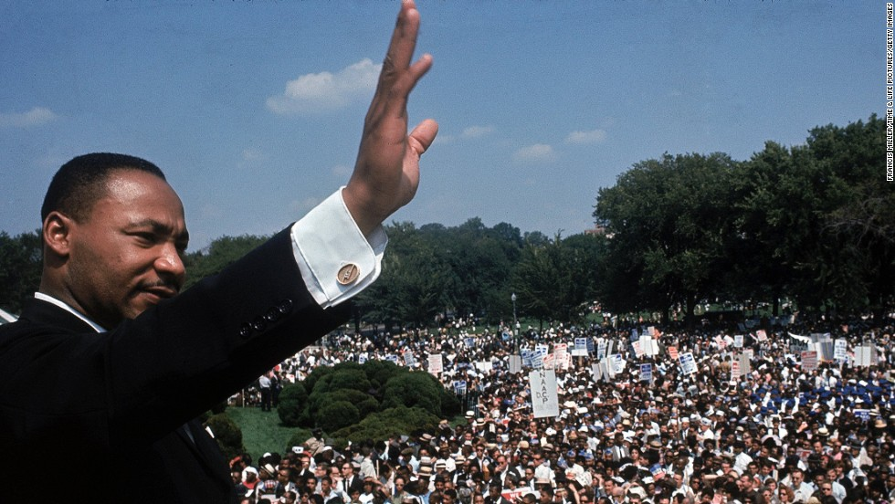
Class 2 (Sept. 4): Identity and Identity Politics
What is identity? What existed before identity politics? What makes an identity political? What are the advantages and limits of identity politics?

Introductions, discussion of the syllabus and assignments, presentation sign up.
James D. Fearon, 1999, “What is Identity (As We Now Use the Word)?” Unpublished.
Linda Nicholson, 2008, Identity Before Identity Politics, Cambridge University Press: Introduction and Epilogue.

Declaration of Independence, 1776: entire (available online).

Declaration of Rights of Man and Citizen, 1789: entire (available online).

Karl Marx and Frederick Engels, The Communist Manifesto, 1848: 14-19 and 34 (Collab).

Declaration of Sentiments and Resolution, 1889: entire (available online).

W.E.B. Du Bois, The Souls of Black Folk, 1903: Section I, “Of Our Spiritual Strivings” (available online).

Combahee River Collective, The Combahee River Collective Statement, 1983: entire (available online).

The Queer Nation Manifesto, 1990: entire (available online).

*Recommended Event
Charlottesville Pride Festival
When: September 9-14; September 14; all day
Location: See the link above

*Recommended Event
Kate Bornstein
Award-winning transgender author, activist, and performance artist
When: September 13; 7pm
Location: Minor Hall, Room 125

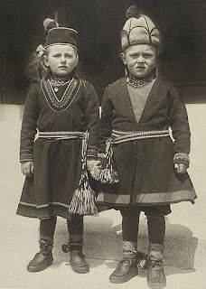

Class 3 (Sept. 11): Approaches to Collective Identity Formation: Ethnicity
Where do political identities come from? Are we born with them? Are they emotional attachments? A product of self-interest? Constructed by political institutions and large structural processes? Or is some combination of these factors at work?

Donald L. Horowitz, 2002, “The Primordialists.” In Daniele Conversi, ed. Ethnonationalism in the Contemporary World: Walker Connor and the Study of Nationalism: Ch. 4 (72-81).

Bates, Robert H., 1983, “Modernization, Ethnic Competition and the Rationality of Politics in Contemporary Africa.” In State vs. Ethnic Claims: African Policy Dilemmas, ed. Donald Rothchild and Victor Olorunsola. Westview.

Mahmood Mamdani, 2001, When Victims Become Killers: Colonialism, Nativism and the Genocide in Rwanda, Princeton University Press: Ch. 2.

Daniel Posner, 2005, Institutions and Ethnic Politics in Africa. Cambridge: Cambridge University Press: Ch. 1 (1-25).
Recommended: Eduardo Bonilla-Silva, 2018, “Feeling Race: Theorizing the Racial Economy of Emotions,” American Sociological Review 84(1): 1-25.
*Recommended Event
Kristina Olson
“Transgender Children: New Evidence”
When: September 16; 3:30-5pm
Location: Gilmer Hall, Room 190

*Recommended Event
Cathy Cohen
“Race, Gender and Vulnerability: The Politics of Millennials in the Era of Trump”
Time: September 17; 3:30-5pm
Location: Rotunda Dome Room

*Recommended Event
Ruth Wodak
“The Politics of Fear: European and Transatlantic Perspectives”
Time: September 17; 4:00-6:00pm
Location: New Cabell Hall 236

Ruth Wodak
“A Conversation about Post/National Identity”
Time: September 18; noon-2pm
Location: New Cabell Hall 236
Please register by Sept. 13; contact info TBA

*Recommended Event
Peter Shinkle
Ike’s Mystery Man: The Secret Lives of Robert Cutler
Time: September 18; 5pm
Location: Nau Hall, Room 342

Part II. Collective Identities

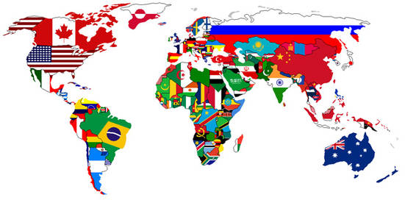

Class 4 (Sept. 18): Nation*
What makes a nation? Why do nationalist appeals sometimes fail and why are they succeeding so much today?

Rogers Brubaker, Margit Feischmidt, Jon Fox, Liana Grancea, 2006, Nationalist Politics and Everyday Ethnicity in a Transylvanian Town. Princeton University Press: Introduction, 4, 12.

Ruth Wodak, 2016, The Politics of Fear: What Right-Wing Populist Discourses Mean, Ch. Ch. 4 and pp. 187-88.

Guest: Professor Emeritus, Ruth Wodak, 5-6pm
- Why are far-right and right-wing populist parties so successful in our times? Why do their messages resonate so well? Why do people believe in lies even when they see that the opposite has happened? What does this tell us about different electorates, the politics of persuasion, media, and anti-establishment politics?

Class 5 (Sept. 25): Indigeneity*
What makes an indigenous people? What makes an indigenous movement?

Deborah Yashar, 2005, Contesting Citizenship in Latin America: The Rise of Indigenous Movements, Cambridge University Press, Ch. 1, 2, 3 and 4.

*Recommended Event
E. Patrick Johnson
“Oral History as Queer Performance: Black Queer Women of the South”
Location: Minor Hall, Room 123
When: September 25, 6pm

*Recommended Event
Spanish, Italian and Portuguese Film Fest
“Visual Narratives of Diversity, Displacement, and Inclusion from the Mediterranean and Latin America”
Location: TBA
When: September 26-30; Time: TBA

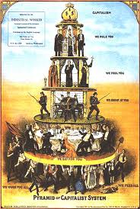

Class 6 (Oct. 2): Class*
What makes a class? What makes a class movement?

Hagen Koo, 2001, Korean Workers: The Culture and Politics of Class Formation, Cornell University Press: Ch. 1, 4, 6, 7.

*No Class October 9: Reading Day*

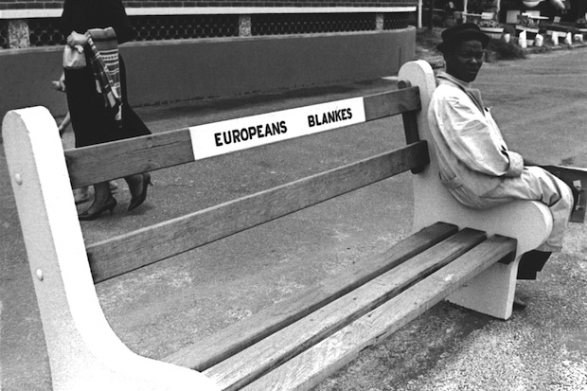

Class 7 (Oct. 16): Race*
What makes a race? What makes racial politics?

Ashley Jardina, 2019, White Identity Politics, Cambridge University Press: Ch. 1, 2.
Karen E. Ferree, 2011, Framing the Race in South Africa, Cambridge University Press: Introduction, Ch. 8.

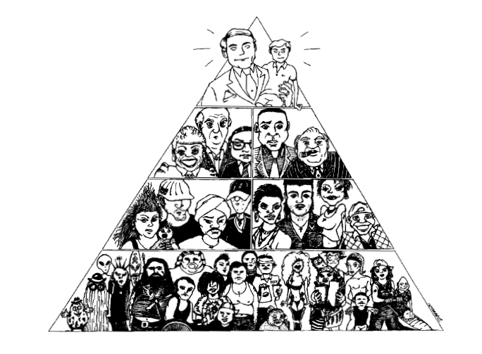
Class 8 (Oct. 23): Gender*
What makes a gender identity? What makes a women’s movement?

Nicaragua: An Unfinished Revolution Parts 1, 2 and 3 for an overview of the Nicaraguan revolution (https://www.youtube.com/watch?v=lxCImH9ZOq0). And the website and trailer of Las Sandinistas! the new film on women in the Nicaraguan revolution that was shown at the 2019 Charlottesville Film Festival.

Lorraine Bayard de Volo, 2001, Mothers of Heroes and Martyrs: Gender Identity Politics in Nicaragua, 1979-1999. Johns Hopkins University Press: Ch. 1, 2.

Lisa Baldez, 2003, “Women’s Movements and Democratic Transition in Chile, Brazil, East Germany, and Poland,” Comparative Politics 35(3): 253-272. NB: Focus on Chile and Poland.

Class 9 (Oct. 30): Sexuality*
What makes a sexual identity? What makes an LGBTQ movement?

Conor O’Dwyer, 2018, Coming Out of Communism: The Emergence of LGBT Activism in Eastern Europe, New York University Press: Ch. 1, 2, 3 and 6.

Extra Credit opporunity: View this new website on queer history at UVa and the exhibit in Newcomb Hall on the third floor.

Part III. Relationships among Politicized Identities
Class 10 (Nov. 6): Competing and Intersecting Identities I*
What made an inclusive women’s identity in South Africa? What made an inclusive women’s movement? What were the obstacles?

Shireen Hassim, 2006, Women’s Organisations and Democracy in South Africa: Contesting Authority, University of Wisconsin Press: Ch. 1, 2, 3 and 5.

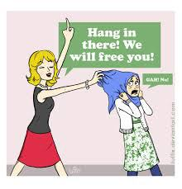
Class 11 (Nov. 13): Competing and Intersecting Identities II*
What made religious identity in France? What made populist politics in France?

Sarah R. Farris, 2017, In the Name of Women’s Rights: The Rise of Femonationalism, Durham: Duke University Press: Introduction, Ch. 1, 3 and 5.

Class 12 (Nov. 20): Research
What makes a good research question? What is the logic for comparative analysis in political science? How can you collect and analyze data?

Review the instructions for the final research project and proposal on the syllabus.

Read: Brooke Ackerly and Jacqui True, 2010, Doing Feminist Research in Political Science and Social Science, Hampshire: Palgrave Macmillan: Ch. 4

Finalize your research question and begin working on your research proposal.
- Be sure to choose an analytical framework and methods that fit your research question.
- Tips:
- Read about how to write a research paper and how to narrow your research topic.
- For general advice browse this site.

Write answers to questions from the worksheet “Research Paper Prep.”

Bring draft copies of your research proposal to class (enough for each student and the instructor). During class, each student will have 8 minutes to discuss the proposal with the class.

After class, read as recommended by the instructor:
- Carol A. B. Warren and Tracy Xavia Karner, 2010, Discovering Qualitative Methods: Field Research, Interviews, and Analysis, Oxford University Press, Ch. 9 (Clemons Reserve).
- Shulamit Reinharz, 1992, “Feminist Interview Research,” Ch. 2. (Collab)
- Sunshine D. Hillygus, “The Practice of Survey Research: Changes and Challenges.” In Adam J. Berinsky, ed., 2016, New Directions in Public Opinion, 2nd edition, Ch. 2 (Collab).
- Herbert Asher, 2017, Polling and the Public, “Wording and Context of Questions” Ch. 3 (Collab).
- James Paul Gee and Michael Handford, 2012, The Routledge Handbook of Discourse Analysis, Taylor and Francis (available as an ebook on Virgo).
- Severine Autesserre, 2012, “Dangerous Tales: Dominant Narratives on the Congo and their Unintended Consequences,” African Affairs 111 (43): 202-222 (Collab).
- Brooke Ackerly and Jacqui True, 2010, Doing Feminist Research in Political and Social Science, Palgrave Macmillan (Clemons Reserve).
- Alexander L. George and Andrew Bennett, 2005, Case Studies and Theory Development in the Social Sciences, Belfer Center for Science and International Affairs: Ch. 3 and 4.

Final Research Proposals due on Collab, Nov. 27 by 11:59 pm.

*Thanksgiving Break: November 27-December 1*

Class 13 (Dec. 4): Sorting Identities*
What is social sorting and how has it made political polarization in the United States?

Lilliana Mason, 2018, Uncivil Agreement: How Politics Became Our Identity, University of Chicago Press: Ch. 1, 2, 3, 4, 5 and 6.

Class 14 (Dec. 11) Mock Conference
The instructor will use student research paper proposals to group papers with shared themes into panels for the last class.

All students will present a 5-minute powerpoint with the following content: research paper question, list of 4-5 big ideas in the literature related to the student’s topic, select evidence that answers the question, a tentative claim, and bibliography to date.

Presentations will proceed in a panel format comprised of 3 presenters each. Each panel will be followed by a 5-minute Q&A from the class. The two students with the best questions and feedback for the presenters will awarded bonus points on the final research paper.

*RESEARCH PAPERS DUE* Dec. 12 at 11:59 pm as an attached file on Collab*
Writing is thinking, and papers require several (many!) drafts. For suggestions on how to revise your research paper see “Rewriting or Revising.” Also see the Writing Tips folder under the Resources tab on Collab.

