University of Virginia
Politics Department
Fall 2015

Denise Walsh PLCP 4500
454 Gibson Hall Gibson Hall 342
Office Hours: T 6-7pm; Th 2-3pm Tuesday: 3:30-6pm
denise@virginia.edu



Culture and Human Rights

Disagreement over culture and human rights is intense. At its worst, this controversy has led cultural conservatives in the Global South to label human rights as imperialist, cultural conservatives in the Global North to reject minority rights as threats to national unity and social democrats, feminists and sexuality rights activists to attack culture as irredeemably retrograde and oppressive. The result has been contestation that crosscuts people’s lives in a struggle that pits the nation, family, and faith against expanding demands for human rights.

The course begins with the emergence of the Universal Declaration of Human Rights and the human rights revolution that brought newly framed demands for social and economic rights, women’s rights, minority rights, and sexuality rights. Next, we examine how challenges to the universality of human rights intensified while obstacles to expanding rights claims proliferated. The core of the course focuses on a series of contemporary human rights controversies from around the globe. Case studies include income inequality within nations, indigenous rights in Latin America and Muslim women’s rights in Europe and India. We conclude with student presentations addressing these controversies.

Course Requirements
Participation (20%)
Student attendance, preparation, and active participation in class are required. Come to class with questions. If you are shy, submit your written questions about the reading at the beginning of class or find another way to demonstrate your engagement with the material.

Questions to ask of all course readings and when doing all class assignments:
1. What is the question the author asks in the article? That is, what is the core problem that the author addresses?
2. What is the author’s claim? (How does s/he answer the question in #1?)
3. What evidence does the author present to support her/his claim? What does this evidence tell us? Why is it important for the argument? (this requires you to be familiar with specific examples from the reading).
4. What is your evaluation of the article? Are you convinced? What questions or criticisms does the author’s argument or use of evidence raise in your mind?
5. If there are problems or weaknesses, what constructive solution might you offer for resolving the issue or strengthening the argument?

Debates: Roundtable and Teams
Students will be divided into groups for the roundtable and team debate. Each group will be assigned its own readings and be charged with debating a resolution. Groups will prepare arguments from their assigned reading that respond to the resolution. Students will come to class as representatives of their author and will argue that position in class.
- Know your material well and be prepared to listen carefully to others. You must ask for points of clarification so you understand the arguments of authors that you did not read.
- Be prepared for other students to challenge your arguments and be prepared to criticize the arguments of others.
- Teamwork is essential. This activity requires everyone to ask questions, make claims, and challenge claims. The more interactive the discussion is, the better your grade.

Discussion Leaders (15%)
In groups of 2, students will sign up for 10-minute presentations during one class session. Class sessions with discussion leaders are designated with an * on the syllabus. Students should meet beforehand to discuss the readings and plan content. Do not divide up the readings. Both student presenters should be experts on all of the assigned material for their session. I expect a conversation between presenters. Assume everyone has done the reading.
Presentation requirements:
- Present the key question of each reading on a slide: 2 sentences maximum per reading. Take the time to discuss this slide so your audience can copy down the information and think about it.
- Present each author’s claim on a slide: 2 sentences maximum per reading. Take the time to discuss this slide so your audience can copy down the information and think about it.
- Discuss 1-2 pieces of evidence or arguments that you think best support the claim. Don’t read quotes or long pages of notes; instead, explain the ideas in everyday language.
- The instructor will stop any presentation that goes beyond 15 minutes.
- In addition to the 10-minute presentation students will design a 5-8 minute class activity, e.g., a mini debate, a film clip, small group activity. Be sure to explain the purpose of the activity and its key points. Failure to do this is to fail the assignment.
- Name your powerpoint by the class number, e.g., Class5.ppt, and post it before class on Collab >Discussion and Private Messages>Worksite Discussions>Powerpoint Presentations>Post Reply.

Discussion Postings (30%)
Each student will post an entry on Collab 8 times during the semester. Discussion posts should be 600-700 words, address themes from all the assigned readings for that day, and present the student’s views on issues raised by the authors. Students must engage with the comments of those who posted before them and raise a question for further discussion. You may summarize concepts, arguments, or debates, although the objective of your writing should be to raise questions and to engage in constructive criticism. Challenge a point, respond to a question, explain why your position is different, ask others what they think about a specific concept, argument, etc. Be clear, concise, and respectful. Writing style matters. This is classroom discussion online, not the blogosphere.

Postings are due before class. No late submissions will be accepted. It is your responsibility to make sure that you post 8 times before Nov. 17. No posts will be accepted after Class #13. Students may not post on readings for which they are serving as discussion leaders. I will randomly select one of your completed posts to grade before midterm and one after midterm. Students are required to bring a hard copy of their posts to class.

To post, go to Collab >Discussion and Private Messages>Worksite Discussions>[class topic that you wish to post on]>Post Reply. NB: All posts should be in one thread. Do not start a separate thread.

Research Proposal (5%)
Proposals should have a one to two sentence question at the top of the page. Do not ask a question that you know the answer to before you do the research. If you already know the answer there is no point in doing the research. Instead, ask a question that is puzzling to you so that you will learn something new. The proposal should also include two paragraphs describing why your question is important, explain how it relates to course themes and to your research plan.

The proposal must also have a correctly formatted bibliography with 3-5 outside sources plus several relevant course readings. Students will do additional activities related to the research project as detailed on the course outline.

Research Paper (30%)
Research papers can be empirical or a combination of theory and empirical material. Topics should be grounded in the themes of the course and must draw on relevant course readings.

Use primary sources whenever possible. Do not just research secondary sources and summarize in your paper what others say. Analyze your material critically, bring it into conversation with divergent points of view and use data. Data can be quantitative or qualitative.

Papers should be 12-15 pages in length, double-spaced. Outside sources and class readings are required. Papers that are mostly empirical may have 25-40 sources; papers with more theoretical material are likely to have less. Include a works cited page (format is up to you, but please be consistent).

All papers must be analytical, not simply descriptive. Descriptive writing answers the questions “what,” “when,” “who.” Analytical papers answer the questions “how” and “why.” Do not make lists of facts, people, events, or even ideas. Instead, focus on posing a question that is contestable, provable, and specific, and then seek evidence to answer it.

Students who wish to receive written feedback on the final research paper must request it on the title page of their paper.

Helpful Resources
The best resource available to you for writing in this course is the UVa Writing Center. Many college writing centers have extensive resources on writing and reading. Here is one example from UNC.

For an overview on what human rights are see James Nickel, 2014, “Human Rights” Stanford Encyclopedia of Philosophy.

The politics department has its own librarian. Mr. Keith Weimer can purchase resources that you need if they are not in the library. He is also available for individual research consultations. Contact him by email: kweimer@virginia.edu

Extra Credit
Students may attend one extra credit event during the semester. If you think an event is course related and would like to attend, confirm with the instructor first. If the event is a talk, students should write a one page, single-spaced report of what they learned, and that includes the question that you asked at the talk and the speaker's response. The write-up must be turned in via email to the instructor within two weeks of the event and will count for up to 5 bonus points to be added to one of the student’s posting grades.

Course Policies
No computers, cell phone, ipads, etc. should ever be used during class without instructor permission.
Do not email me if we can discuss your question before or after class or during my office hours. I will not answer emails that do not follow this protocol.
Do not send me an email with a question that is answered on this syllabus. Always check with another student in the class first.
Use UVa Box to backup your work in real time; backup your entire computer on an external hard drive regularly. No extensions for lost work necessary because you will never lose work.
Follow the honor code. If you have a question about plagiarism, ask.
Students turn in all work for this course on Collab. When turning in assignments, check to see that your assignment was successfully submitted, and that you submitted the correct assignment.
Late discussion postings and presentations from discussion leaders are not accepted.
Late research papers and proposals lose 3 points each day for the first two days. Later work will only be accepted as determined by the instructor.
All students are expected to attend every class session with the exception of illness or an emergency. All other absences will be unexcused and detract from your participation grade. In the event of an excused absence, arrange to get the information from another student in the class.
For information about my research, courses, advising, etc., please consult my website.

Required Readings
Kate Pickett and Richard Wilkinson, 2009, The Spirit Level: Why Greater Equality Makes Societies Stronger, Bloomsbury Press, available new on Amazon for $11.45.

Deborah Yashar, 2005, Contesting Citizenship in Latin America: The Rise of Indigenous Movements, Cambridge University Press, available new on Amazon for $37.50. Used copies available for less on Amazon.

These books are on reserve in Clemons under PLCP 4500. Used copies may be available at the bookstore. It also is readily available online. All other readings are on Collab or can be located by clicking the hyperlinks on the syllabus.

*Occasional changes to the syllabus are possible and will be announced in advance.
NB: If you or someone you know is struggling with gender, sexual, or domestic violence or is a target of a hate crime there are many community and University of Virginia resources available including Just Report It, The Office of the Dean of Students: 434- 924-7133 (after hours and weekends 434-924-7166 for the University Police Department; ask them to refer the issue to the Dean on Call), the UVA Women's Center: 435-982-2361, Sexual Assault Resources Agency (SARA) hotline: 434-977-7273 (24/7), Shelter for Help in Emergency (SHE) hotline: 434-293-8509 (24/7). If you prefer to speak anonymously and confidentially over the phone to UVa student volunteers, call Madison House's HELP Line (24/7): 434-295-8255.
Course Outline.
Part I: Generations of Rights
C1 (August 25): The Historical Emergence of Human Rights
How do human rights campaigns emerge and what factors led to the rights revolution?

Discussion of class policies, the syllabus, and assignments.

Margaret Keck and Kathryn E. Sikkink, 2014, Activists beyond Borders: Advocacy Networks in International Politics, Cornell University Press: Ch. 2 (p. 39-78) (available as an ebook on Virgo)

Alison Brysk, 2013, Speaking Rights to Power: Constructing Political Will, Oxford University Press: Ch. 2 (p. 41-55 on Collab) (also available as an ebook on Virgo).

“Eleanor Roosevelt and the Universal Declaration of Human Rights,” and her very short speech, “Adoption of the Declaration of Human Rights 1948,”

The Universal Declaration of Human Rights, 1948.

Charles R. Epp, 1998, The Rights Revolution: Lawyers, Activists, and Supreme Courts in Comparative Perspective, University of Chicago: Ch. 1 and 2 only.

In class: Human Rights

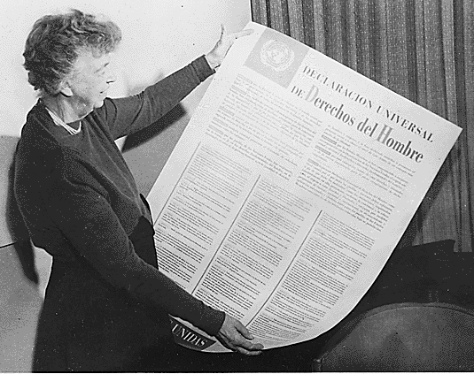

C2 (Sept. 1): CANCELLED. I will be in San Francisco at the annual American Political Science Association Conference.

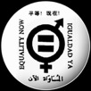

Last day for adding classes: Sept 8

C3 (Sept 8): First Generation Rights: Women’s Rights and Sexuality Rights*
What are first generation rights? How and why have they expanded?

Aili Mari Tripp, 2006, “The Evolution of Transnational Feminisms: Consensus, Conflict, and New Dynamics,” in Myra Marx Ferree and Aili Mari Tripp, eds., Global Feminism: Transnational Women's Activism, Organizing, and Human Rights, New York, University Press: 51-75.

Convention on the Elimination of all forms of Discrimination Against Women, 1979.

Fourth World Conference on Women Beijing Declaration, 1995.

Kelly Kollman, 2013, The Same-Sex Unions Revolution in Western Democracies: International Norms and Domestic Policy Change. Manchester University Press: Ch. 1 and 5.

Declaration of Montreal: LGBT Human Rights (2006)

Last day to drop a class: Sept 9



C4 (Sept. 15): Second and Third Generation Rights: Social and Economic Rights; Indigenous Rights*
What are second and third generation rights? How and why have they expanded?

International Covenant on Economic, Social and Cultural Rights

Wade M. Cole, 2013, “Strong Walk and Cheap Talk: The Effect of the International Covenant of Economic, Social, and Cultural Rights on Policies and Practices,” Social Forces 92(1): 165-194.

United Nations Millennium Declaration

Deborah Yashar, 2005, Contesting Citizenship in Latin America: The Rise of Indigenous Movements, Cambridge University Press: Ch. 1-3 (p. 3-84)

United Nations Declaration on the Rights of Indigenous Peoples, 2007.

In class: Indigenous Peoples+ UN Vol. 1; Justice for Aboriginal Peoples – It’s About Time

Part II: Obstacles to Rights
C5 (Sept 22): Universal Rights*
Is the UDHR really universal?

Fareed Zakaria, 1994, “A Conversation with Lee Kuan Yew,” Foreign Affairs, Vol. 73, No. 2, March/April: 109-127.

Jack Donnelly, 1999, “Human Rights and Asian Values: A Defense of ‘Western’ Universalism,” in Joanne R. Bauer and Daniel A. Bell, eds., The East Asian Challenge for Human Rights, Oxford University Press: 60-87.

Pedro Pitarch, 2008, “The Labyrinth of Translation: A Tzeltal Version of the Universal Declaration of Human Rights,” in Human Rights in the Maya Region, ed. Pedro Pitarch, Shannon Speed, and Xochitl Leyva Solano, Duke University Press: 91-122.

To watch before class: Lee Kuan Yew Interview (0:00-5:00), The Best of Lew Kuan Yew (0:00-4:28), BBC World News – Singapore’s Founding Father (3:04-6:40)

Come to class with a list of pros and cons for universalism and cultural relativism. Be ready to state your position.

C6 (Sept 29): Women’s Rights and Sexuality Rights*
Are women’s rights and sexuality rights universal?

Ann Elizabeth Mayer, 1995, “Rhetorical Strategies and Official Policies on Women’s Rights: The Merits and Drawbacks of the New World Hypocrisy,” in Mahnaz Afkhami, ed., Faith and Freedom: Women’s Human Rights in the Muslim World, Syracuse University Press: 104-132.

Lisa Baldez, 2014, Defying Convention: US Resistance to the U.N. Treaty on Women’s Rights. New York: Cambridge University Press: Ch. 2.

Thabo Msibi, 2011, “The Lies We Have Been Told: On (Homo)Sexuality in Africa,” Africa Today September (1): 55-76.

Ashley Currier, 2012, Out in Africa: LGBT Organizing in Namibia and South Africa, University of Minnesota Press: Ch. 4 (p. 121-150) (available as an ebook on Virgo)

In class: “Women and Men Do Not Have Equal Rights,” “Maternity Leave Infographic; God Loves Uganda; Call Me Kuchu (click here for more information); Uganda Court Annuls Anti-homosexuality Law

C7 (Oct 6): No Class - Reading Day



C8 (Oct. 13): Second Generation Rights and Multiculturalism*
Are second generation rights and multiculturalism universal?

Daniel Chong, 2009, “Five Challenges to Legalizing Economic and Social Rights,” Human Rights Revolution (10): 183-204.

Yeheskel Hasenfeld and Eve E. Garrow, 2012, “Nonprofit Human-Service Organizations, Social Rights, and Advocacy in a Neoliberal Welfare State,” Social Service Review (June): 295-322.

Yasemin Nuhoglu Soysal, 2012, “Citizenship, Immigration, and the European Social Project: Rights and Obligations of Individuality,” The British Journal of Sociology 63 (1): 1-21.

Kenan Malik, 2015, “The Failure of Multiculturalism,” Foreign Affairs 94 (2): 21-32.

In class: “Rise of the far-right extremism in Europe” (1:08-4:02)

Last day to withdraw from a class: Oct. 20

Part III: Case Studies of Human Rights Controversies
C9 (Oct 20): Income Inequality*
Should there be a right to an equal standard of living? Why do some countries value income equality more than others?

Kate Pickett and Richard Wilkinson, 2009, The Spirit Level: Why Greater Equality Makes Societies Stronger, Bloomsbury Press: Ch. 1-4; 14 and 16

Richard Wilkinson Ted Talk
Forthcoming Film: The Divide

Reminder: All students must complete 8 discussion postings by Class #13 (Nov. 17)

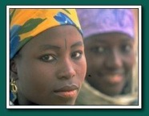

C10 (Oct 27): Bodily Integrity - Roundtable Debate
Which body modifications are rights and which are violations of bodily integrity? Why?

Students will be assigned one reading from the following list to debate:
Group A:
1. R.J. Cook, B.M. Dickens, M.F. Fathalla, 2002, “Female Genital Cutting (mutilation/circumcision): Ethical and Legal Dimensions,” International Journal of Gynecology & Obstetrics 79: 281-287
2. Richard Shweder, 2000, “What About ‘Female Genital Mutilation’? And Why Understanding Culture Matters in the First Place,” Daedalus, Vol. 129, No. 4: 209-232.

Resolved: Female Genital Cutting is a violation of bodily integrity that should be eradicated.

Group B:
3. Leslye Amede Obiora, 2000,“Bridges and Barricades: Rethinking Polemics and Intransigence in the Campaign Against Female Circumcision,” in Adrien Katherine Wing, Global Critical Race Feminism: An International Reader, New York University Press: 260-274.
4. Isabelle R. Gunning, 2000,“Uneasy Alliances and Solid Sisterhood: A Response to Professor Obiora’s ‘Bridges and Barricades,” in Wing: 275-284.

Resolved: Female Circumcision is a cultural practice that should be medicalized.

Group C:
5. Wairimu Ngaruiya Njambi, 2004, “Dualisms and Female Bodies in Representations of African Female Circumcision,” Feminist Theory Vol. 5, No. 3: 281-303.
6. Cheryl Chase, 2002,“’Cultural Practice’ or ‘Reconstructive Surgery?’ U. S. Genital Cutting, the Intersex Movement, and Medical Double Standards,” in Stanlie M. James and Claire C. Robertson, eds., Genital Cutting and Transnational Sisterhood: Disputing U.S. Polemics, University of Illinois Press: 126-151.

Resolved: “Natural” bodies are bodies that are circumcised.

Group D:
7. Morgen L. Thomas, 2012, “Sick/Beautiful/Freak: Nonmainstream Body Modification and the Social Construction of Deviance,” SAGE Open (2): 1-12.
8. Bethany Stevens, 2011, “Interrogating Transability: A Catalyst to View Disability as Body Art,” Disability Studies Quarterly 31 (4): n.p.
Clip: Joel Reynolds, 2014, “Transability or Your Body is Not What You Think It Is,” TEDx Talks

Resolved: Bodily modifications that are aesthetic rather than disabling should be respected as expressions of personal identity.

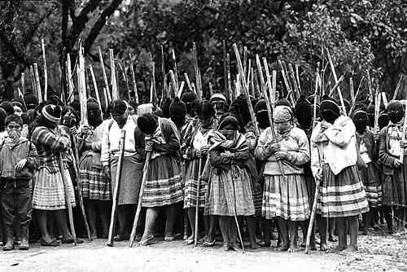

C11 (Nov 3) Neoliberalism and Indigenous Struggles*
How and why does neoliberalism use indigenous rights?

Charles R. Hale, 2005, “Neoliberal Multiculturalism: The Remaking of Cultural Rights and Racial Dominance in Central America,” PoLAR: Political and Legal Anthropology Review 28 (1): 10-28.

Nancy Grey Postero, 2007, Now We are Citizens: Indigenous Politics in Postmulticultural Bolivia, Stanford University Press: Ch. 1 (p. 1-22).

Suzana Sawyer, 2004, Crude Chronicles: Indigenous Politics, Multinational Oil, and Neoliberalism in Ecuador, Duke University Press: Opening (p. 1-26) and Ch. 4 (p. 118-148).

C12 (Nov 10): Strange Bedfellows*
What is the relationship between second generation rights and sexuality rights? How and why do conservatives use sexuality rights?

Angelia R. Wilson, 2013, Why Europe is Lesbian and Gay Friendly (and Why America Never Will Be), State University of New York: Ch. 4 and 5.

Momin Rahman, 2014, “Queer Rights and the Triangulation of Western Exceptionalism,”
Journal of Human Rights,” 13 (3): 274-289.

Karen Zivi, 2014, “Performing the Nation: Contesting Same-Sex Marriage Rights in the United States,” Journal of Human Rights 13(3): 290-306.

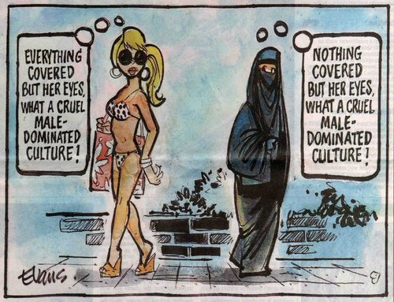

C13 (Nov 17): What Not to Wear in Europe
How and why is freedom of expression gendered in Europe? Are European objections to the veil a defense of women’s rights?

All students read the first three readings plus one of the team debate readings:
Linda Duits and Liesbet van Zoonen, 2006,“Headscarves and Porno-Chic,” European Journal of Women’s Studies 13 (2): 103-117.

Rosalind C. Gill, 2007, “Critical Respect: The Difficulties and Dilemmas of Agency and ‘Choice’ for Feminism,” European Journal of Women’s Studies 14 (1): 69-80.

Linda Duits and Liesbet van Zoonen, 2007, “Who’s Afraid of Female Agency?” European Journal of Women’s Studies 14 (2): 161-170.

Team Debate
Benjamin D. Bleiberg, 2005,”Unveiling the Real Issue: Evaluating the European Court of Human Rights’ Decision to Enforce the Turkish Headscarf Ban in Leyla Sahin v. Turkey,” Cornell Law Review 91(1): 129-169.

Karima Bennoune, 2007, “Secularism and Human Rights: A Contextual Analysis of Headscarves, Religious Expression, and Women’s Equality under International Law,” Columbia Journal of Transnational Law: 367-426.

Resolved:
- The ECHR was right to ban headscarf to protect gender equality.
- The ECHR was right to ban the headscarf to protect Turkish democracy.
- The ECHR was wrong to ban headscarf because it violated the right to religion.
- The ECHR was wrong to ban headscarf to protect Turkish secularism.

*Overview of Research Paper Assignment

C14 (Nov 24): Research Proposals Due on Collab by 6pm
What makes a good research question and a good research paper?

Brooke Ackerly and Jacqui True, 2010, Doing Feminist Research in Political Science and Social Science, Ch. 4 (Collab).

Remember: a good research question is contestable, supportable and specific.

Read about how to do a research paper for strategies on how to narrow your research topic. For general tips browse this site; and check out this last one for strategies on how to make a convincing argument. Click here for a parody of Mary Kate Olson on the difference between reasons and evidence, and here for a clip from the TV show “Mythbusters” on evidence.

The instructor will use the proposals to group student papers with shared themes into panels for the last class.

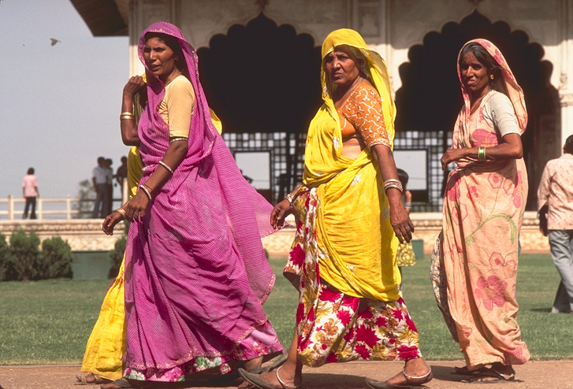

C15 (Dec 1): The Politics of Rights
How do conflicts over multiculturalism and women’s rights get resolved? Why?

The Shah Bano Case: simulation using online materials

Bring a hard copy of your revised research paper question.

C16 (Dec 8): Mock Conference
All students will present a 5 minute powerpoint with the following content: research paper question, list of 4-5 big ideas in the literature related to the student’s topic, select evidence thus far that answers the question, a tentative claim, and bibliography to date.

Presentations will proceed in a panel format comprised of 3-4 presenters each. Each panel will be followed by a 5 minute Q&A from the class.

Bonus points on the research paper will be awarded to the two students with the best questions and feedback for the presenters.

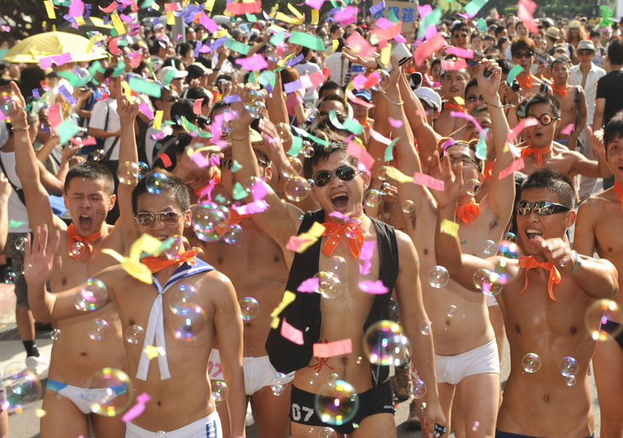

*RESEARCH PAPERS DUE* by Dec 14 at 5pm, as an attached file on Collab*
Writing is thinking, and papers require several drafts. For suggestions on how to revise your research paper see “Rewriting or Revising.” Also see the Writing Tips folder under the Resources tab on Collab.

